**18th December, 2014**

To

The Indian High Commission,

Indian Embassy

**(country)**

Dear Sir/Ma’am,

Subject: Issue of VISA.

AIESEC is the International Association of Students in Economics and Commerce Sciences. It is a non-profit, educational and student run organization, with a worldwide member base of 125 countries and spread across 2100 universities. Since it’s foundations in 1948, AIESEC has been organizing student exchanges between countries of its network, during which students from one country work in a foreign country.

Our organization is participating in AIESEC’s Global Community Development Program, in terms of which a student from (**country**) will work here, in Kolkata, India. This person is **(Full name**), with passport number **(number)**. **He** will be working in an organization for a period of 6 weeks, starting on **(start date)** and ending on **(end date).**

**He** will be accommodated in the city where AIESEC will arrange for the accommodation. All costs during **his** internship shall be borne by the intern. The details of the internship are as follows:

About the Organization –

Name:

|  |  |  |  |  |  |  |  |  |  |
| --- | --- | --- | --- | --- | --- | --- | --- | --- | --- |
| Job Descriptions:   |  |  | | --- | --- | |  |  | | 1 | | 2 | | 3 | | 4 | | Measurable results expected from the intern: |  |   Department in which the intern will be working: | |
|  |  |
|  |  |
|  |  |
|  |  |
|  |  |
|  |  |
|  |  |

The Passport details of the intern are as follows:

Name:

Parent Name:

Address:

Passport Number:

Passport Expiry Date:

We therefore request you to grant **(name)** with a VISA for 6 weeks starting from (**start date)** to **(end date),** in order for **him** to come to AIESEC Kolkata and work with us.

With regards,

Official Organisation stamp:



Company/organisation representative name: **(name)**

**LC representative signature**

Sincerely,

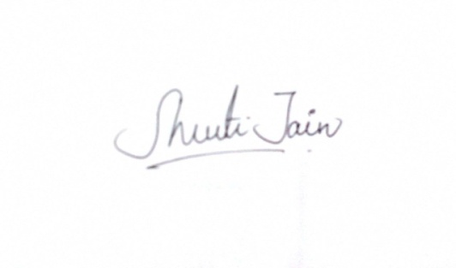

**Shruti Jain**

Vice President | Global Citizen Program- Incoming Exchange

Local Committee: AIESEC in Kolkata

AIESEC India

Dated: **18/12/2014**